**BlueCat Address Manager Setup Guide**

BlueCat Address Manager is a powerful IP Address Management software that lets you control your complex and dynamic network with integrated core services, workflow and automation. You can certainly manage every connected device on your network from a single pane of glass with BlueCat.

This guide illustrate you, how to install and configure BlueCat Address Manager in such a way to integrate with Cisco Cloud Center Workload Manager.

**VMware Installation:**

BlueCat Virtual Machines are delivered in OVA (Open Virtual Appliance) format, compatible with VMware ESX/ESXi server 6.7, 6.5 and 6.0 Update 3.

Customers using VMware Workstation, Server or Fusion should import the OVF or use VMware's standalone converter to convert the OVF into a format compatible with VMware Server/Workstation 1.0.x/6.x+. BlueCat customers should use VMware ESX, ESXi or vSphere for other environments, and may use VMware Workstation or Server for lab environments or evaluation.

If you still require the OVF image, extract the OVF file from the compressed OVA package using an extraction utility.

**Note:** Installing Address Manager and DNS/DHCP Server v8.1.0 and greater on VMware ESXi might result in multiple PCI error messages appearing during the boot of clean installations. The messages are harmless and do not impact service or performance. For more information, refer to Knowledge Base article 15322 on BlueCat Customer Care.

**Note:** If you still require the OVF image, extract the OVF file from the compressed OVA package using an extraction utility.

**System requirements:**

For optimum performance, BlueCat recommends reserving resources in your hypervisor for each specific DNS/DHCP Server and Address Manager VM.

Address Manager and DNS/DHCP Server virtual machines support hyper-threading and hyper-threading is enabled by default. In addition, Address Manager and DNS/DHCP Server can now use all CPU cores (including hyper-threaded cores) for improved performance on virtual machines.

Address Manager VM images require 320GB of disk space.

|  |  |  |  |  |  |
| --- | --- | --- | --- | --- | --- |
| **Product** | **# of vCPUs** | **CPU resource**  **allocation**  **(MHz)** | **CPU clock**  **speed (GHz)** | **vRAM (GB)** | **Network**  **Adapters** |
| BlueCat  Address  Manager 1000 | 1 | 2000 | 2.0 | 4 | 1 |

**Note:** BlueCat Address Manager 1000 only manages a maximum of 4 DNS/DHCP Servers.

|  |  |  |  |  |  |
| --- | --- | --- | --- | --- | --- |
| BlueCat  Address  Manager 3000 | 8 | 24000 | 3.0 | 16 | 1 |
| BlueCat  Address  Manager 6000 | 16 | 41600 | 2.6 | 32 | 1 |
| BlueCat  GEN4-5000  (BAM5000) | 6-12  BlueCat  recommends  configuring 12  vCPU cores. | 198005 | 3.3 | 32 | 3 |
| BlueCat  GEN4-7000  (BAM7000) | 12-20  BlueCat  recommends  configuring 16  vCPU cores. | 440006 | 2.2 | 32-64  BlueCat  recommends  configuring  64GB of vRAM. | 3 |

**Installing Virtual Machines in VMware:**

These steps explain how to install Address Manager and DNS/DHCP Server virtual machines in a VMware environment.

Prior to installing an Address Manager or DNS/DHCP Server VM, make sure that you have created a

resource pool in your vSphere Client with the required resources allocated.

Address Manager and DNS/DHCP Server virtual machines are delivered in OVA (Open Virtual Appliance) format. If you still require the OVF image, extract the OVF file from the compressed OVA package using an extraction utility.

**Note:** Address Manager and DNS/DHCP Server ISO installations are not supported on virtual machines.

1. Click the resource pool. From the **File** menu, select **Deploy OVF template**. The *Deploy OVF Template wizard* opens and displays the *Source* page.
2. Click **Browse**. An *Open* dialog box appears. Find and select a BlueCat Virtual machine OVAOVF file and click **Open**. The selected file appears in the **Deploy from a file or URL** text box. Click Next. The *OVF Template Details* page opens.
3. Verify OVF template details and click **Next**. The *Name and Location* page opens.
4. In the **Name** field, type a name for the virtual machine and click **Next**. The *Datastore* page opens.
5. Select a destination storage for the virtual machine file and click **Next**. The *Disk Format* page opens.
6. Select the format in which you want to store the virtual disk and click **Next**. In the **Name** field, type a name for the virtual machine and click **Next**. The *Network Mapping* page opens.
7. Select a destination network for the virtual machine and click **Next**. The *Ready to Complete* page opens.

**Note:**

* + You should have at least one network to map to the management interface (eth0).
  + If you want to use a multi-interface DNS/DHCP Server, you must configure additional network adapters from VMware settings after the deployment is complete

1. Click **Finish**.

When deployment is complete, the *Deployment Completed Successfully* dialog box opens.

1. Click **Close**.

**Configuring BlueCat Address Manager from Administration console:**

**Steps:**

1. Select the BlueCat instance launched in the VMware Data center.

2. Launch the Web Console of that instance.

3. For console login use default credentials.

**username**: admin and **password**: admin .

4. ***Setting an IPv4 address***

To configure an IPv4 address and netmask:

* From Main Session mode, type **configure interfaces** and press ENTER.
* Type **modify <interface>** and press ENTER.
* Type **set address <ipv4address/netmask>** and press ENTER.
* Type **save** and press ENTER. The Administration Console saves your settings.
* Type **exit** and press ENTER until you return to Main Session mode.

Once you have set the IP address and netmask and saved your settings, you must set the default IP gateway from Network Configuration mode.

**Note:** Proved the valid available IPv4 address from the network you installed the BlueCat Address Manager in the VMWare Data Center.

***5. Setting the default gateway:***

Set the default IPv4/IPv6 gateway after setting IPv4/IPv6 address and netmask.

To set the default gateway

* From Main Session mode, type configure*network*and press ENTER.
* Type *set default-gateway <ipv4/ip6address>* and press ENTER. If your gateway does not match your interface, you will receive an error. Enter the set gateway command again with the correct gateway address, or modify the IP address in Interfaces Configuration mode.
* Type *save* and press ENTER. The Administration Console saves your settings.
* Type *exit* and press ENTER until you return to Main Session mode.

After you have configured the interface and network options the Address Manager web interface should be available on the network.

**Example:**

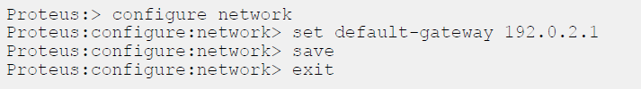

***6. Managing Virtual Machine Licenses:***

Get the license from the "BlueCat" for BlueCat Address Manager.

Address Manager and DNS/DHCP Server virtual machine licenses eventually expire and must be renewed. Address Manager and DNS/DHCP Server virtual machines provide Administration Console commands that you can use to view and update your license keys.

A virtual machine license includes a grace period of 30 days after its formal expiry date. During this period, a warning message appears in the Administration Console every 10 minutes to remind you that your license has expired. If you do not renew your license before the grace period ends, Address Manager and DNS/DHCP Server prevent the deployment of data, but services do not stop.

**Updating the license:**

Ensure that the license client ID is 15-characters long. The activation key contains five sets of five alphanumeric characters <XXXXX-XXXXX-XXXXX-XXXXX>.

You can update the license using either the configure interactively command or the configure ClientID command. BlueCat recommends using the update interactively command.

***Steps:***

* From Main Session mode, type *configure license* and press ENTER.

Perform one of the followings:   
- If updating by using update interactively command, type update interactively and press ENTER.

**-** If updating by using update clientID, type update clientID <XXXXXXXXXXXXXXX> key <XXXXX-XXXXX-XXXXX-XXXXX> and press ENTER. If the key is valid, go to previous step If you receive an error, check the key and try again.

* At the activation key prompt, type Y
* Enter the client ID. If the key is valid, go to next step. If you receive an error, check the key and try again.
* Enter the activation key. If the key is valid, go to next step. If you receive an error, check the key and try again
* Press any key to continue. The client ID and activation key are saved. You are returned to the license configuration mode prompt

7.**Adding name-server information***:*

* From Main Session mode *type configure name-server* press ENTER
* Type add addess <DNS server address> and press ENTER
* Type add domain-name <DNS server name> press ENTER
* Type save and press ENTER
* Type exit and press ENTER until you return to Main Session mode

**Configuring using BlueCat Address Manager User Interface:**

**Creating a new User with admin access, GUI and API permissions:**

By default, admin has only GUI access permissions so we need to create a user with API and GUI permissions.

**Steps to create a new user:**

Go to ***Administration*** tab

1. Select ***users and Groups*** from the ***User Management*** module:

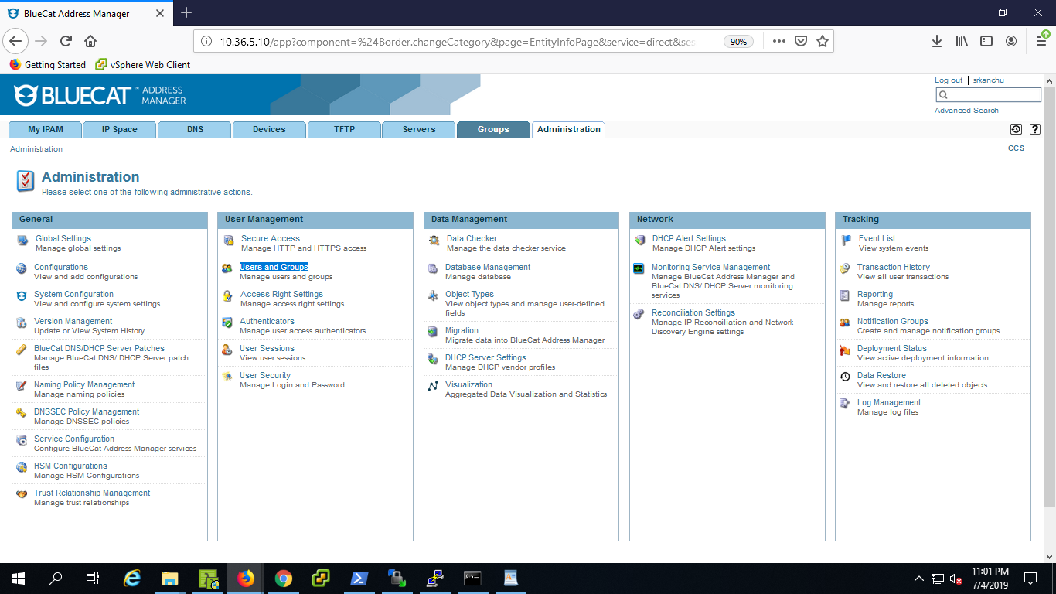

2. From Users and Groups select ***Users*** tab and click on **New.**

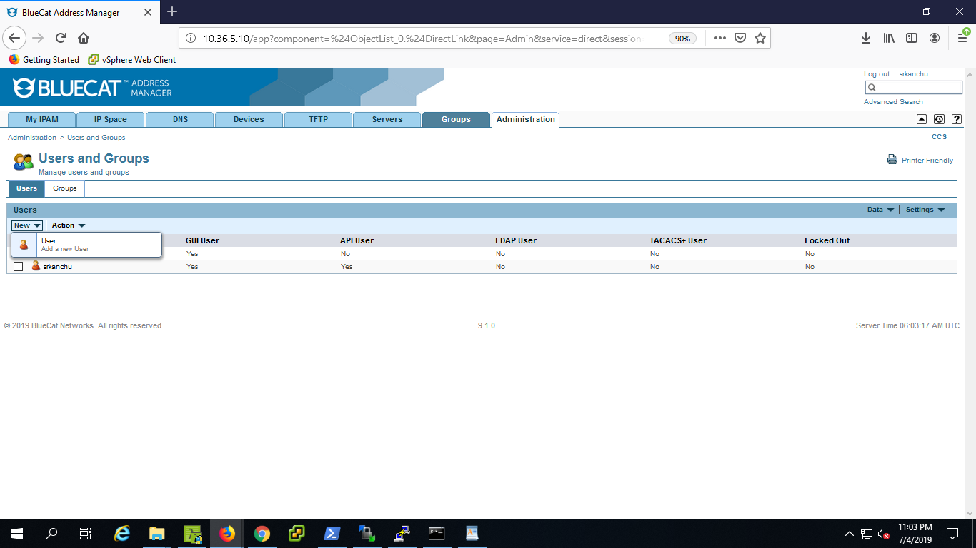

3. Give the required values for username, password etc.

4. In ***User Access section*** Select the ‘***Administrator***’ and ‘***access type*** ‘ select "***GUI and API*** " and click on ***add.***

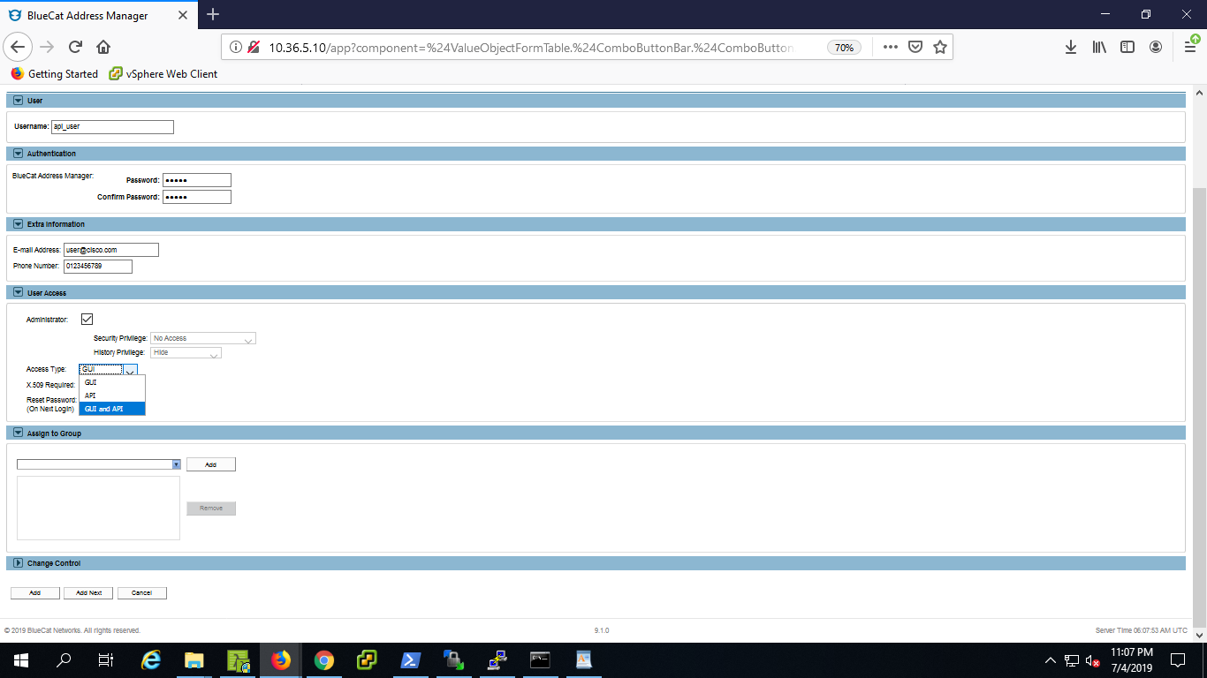

**Creating a Configuration:**

A configuration is a collection of settings representing a specific network implementation. In the Address Manager object structure, the configuration is the parent IPAM object, encompassing all other objects in the network.

You can create multiple configurations to maintain different networks and to perform testing in an isolated environment without interfering with production servers.

**Steps:**

1**.** Select the **Administration** tab. Tabs remember the page on which you last worked, so select the

**Administration** tab again to ensure you are working on the *Administration* page.

2**.** Navigate to **General** > **Configurations** and select **New Configuration**. The *Add Configuration* page opens.

3. In the **Name** field, type a name for the configuration.

4.Click **Add**.

**Creating a custom field ‘Gateway’:**

User need to create one custom field “**Gateway**” in the Ipv4 Network object.

**Steps:**

1. Go to ***Administration*** tab and select ***Object types*** in ***Data management*** panel.

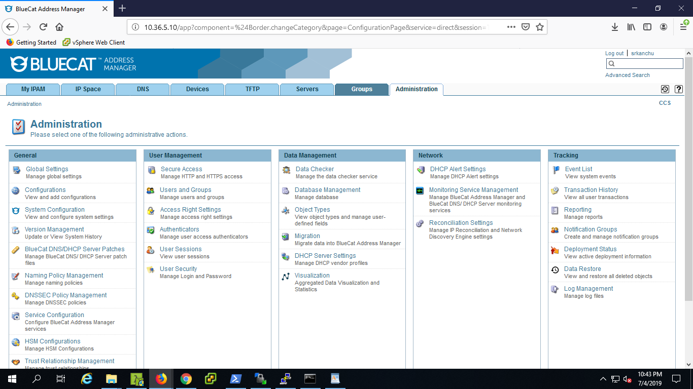

2. Select ***IPv4 Objects*** from ***Object categories.***

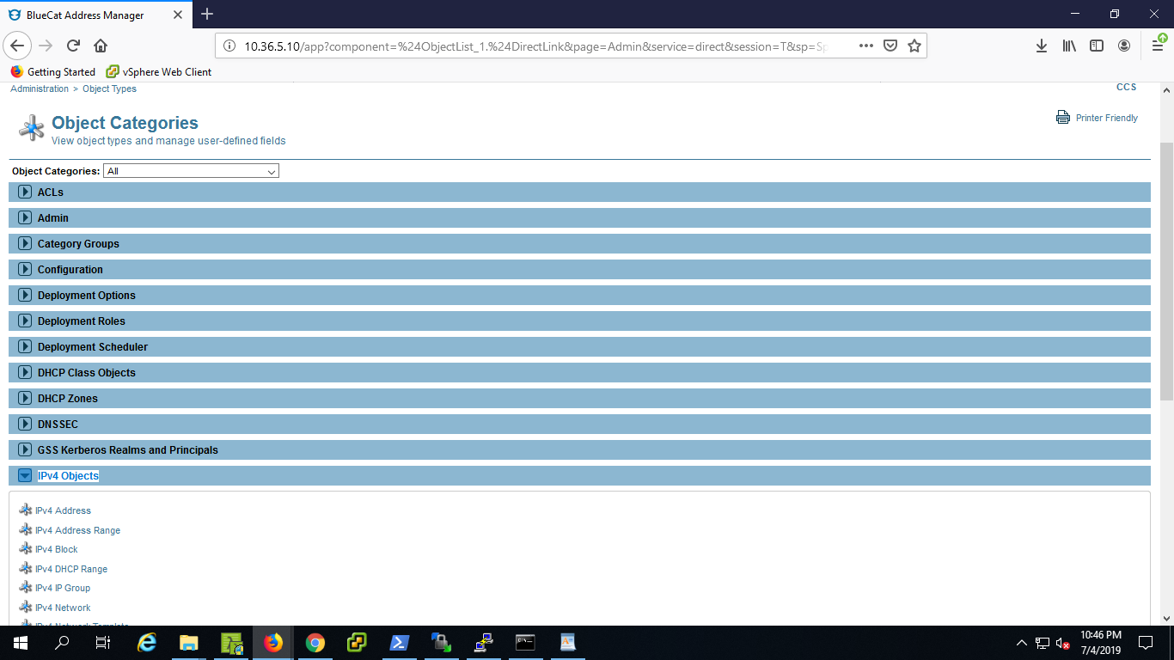

3. Click on ***IPv4 Network*** from ***IPv4 Objects*** in the list.

4. In **fields** section create a new User-Defined field "Gateway"

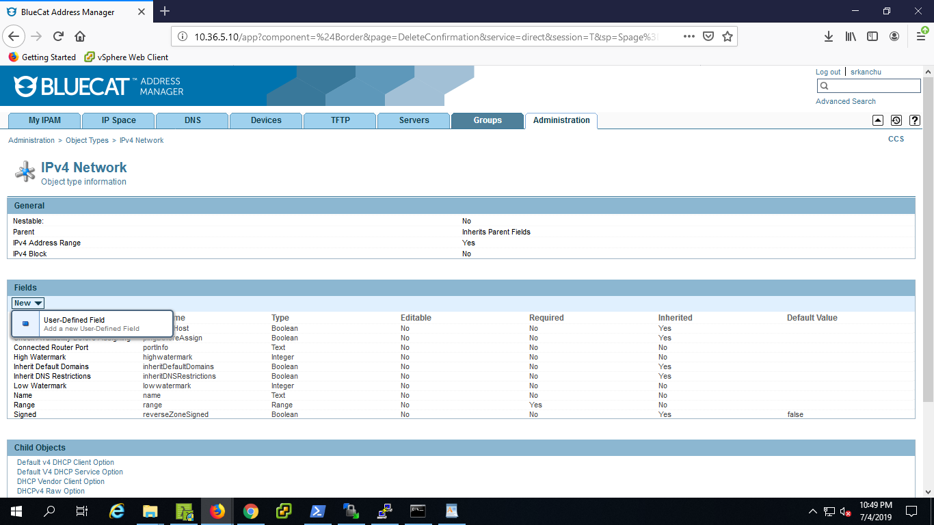

5. Give name "***Gateway***", display name "***Gateway***" and type : "***Text***" and click on ***Add.***

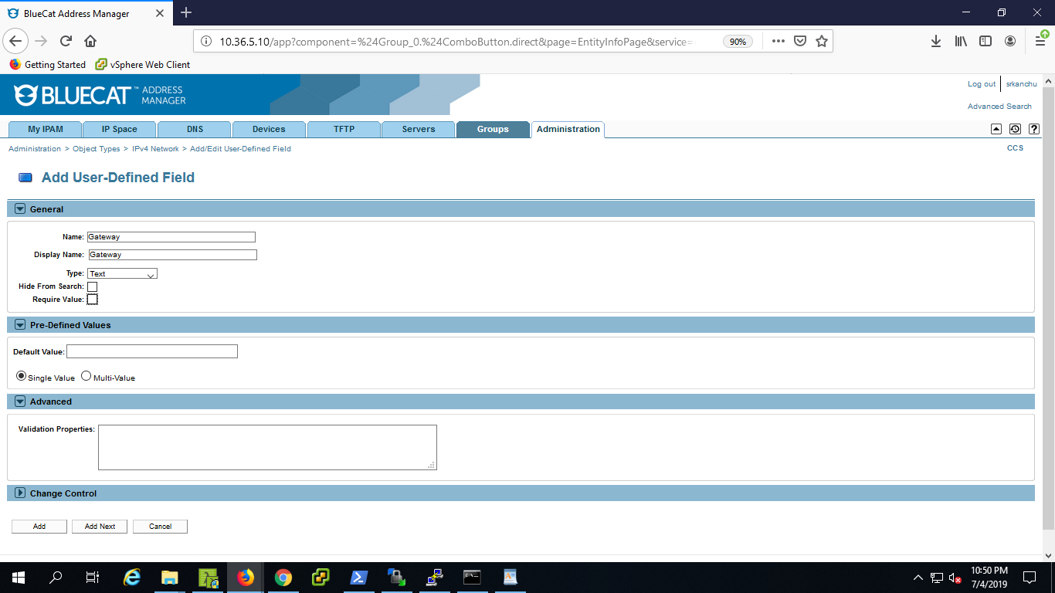

**Creating DNS View and Zone:**

**Steps:**

1. Go the ***DNS*** tab in your selected ***configuration***.

2. Select ***view*** tab.

3. Create new view.

4. Give some Name and click on **Add.**

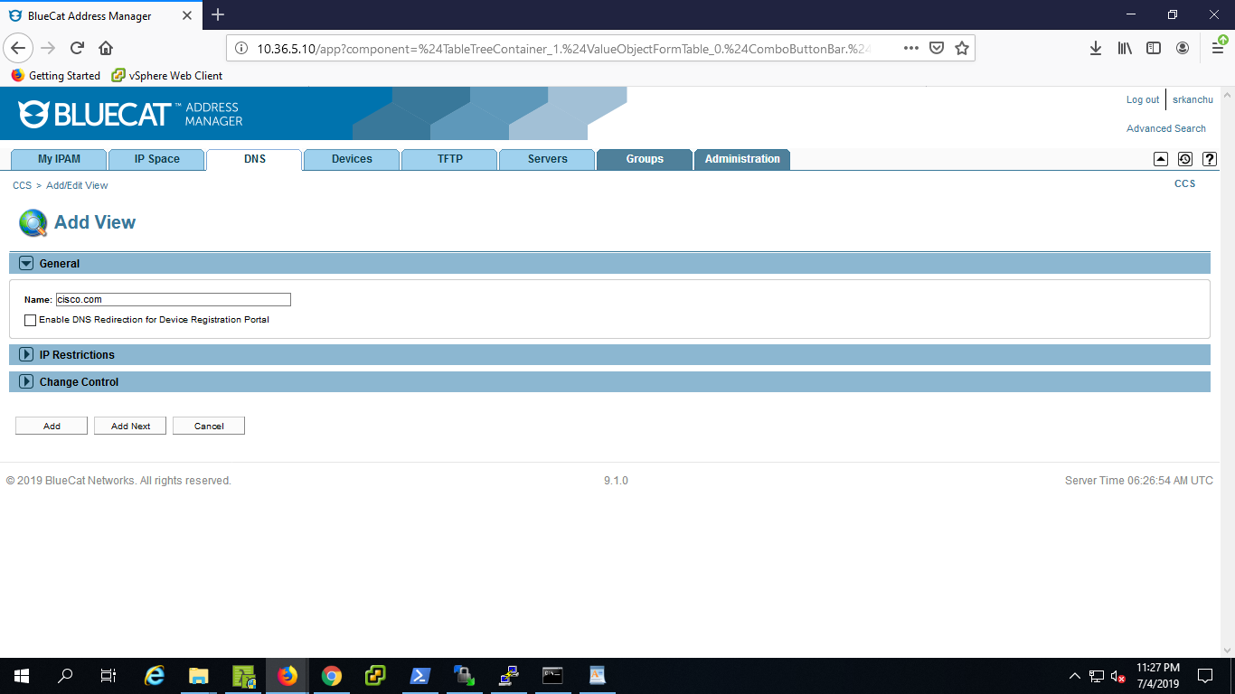

5. Click on the view you created from the ***views*** tab.

6. Click on ***Zones*** tab in the view created. Click on ***new*** for creating the new zone.

7. Give some name and click on ***Add***.

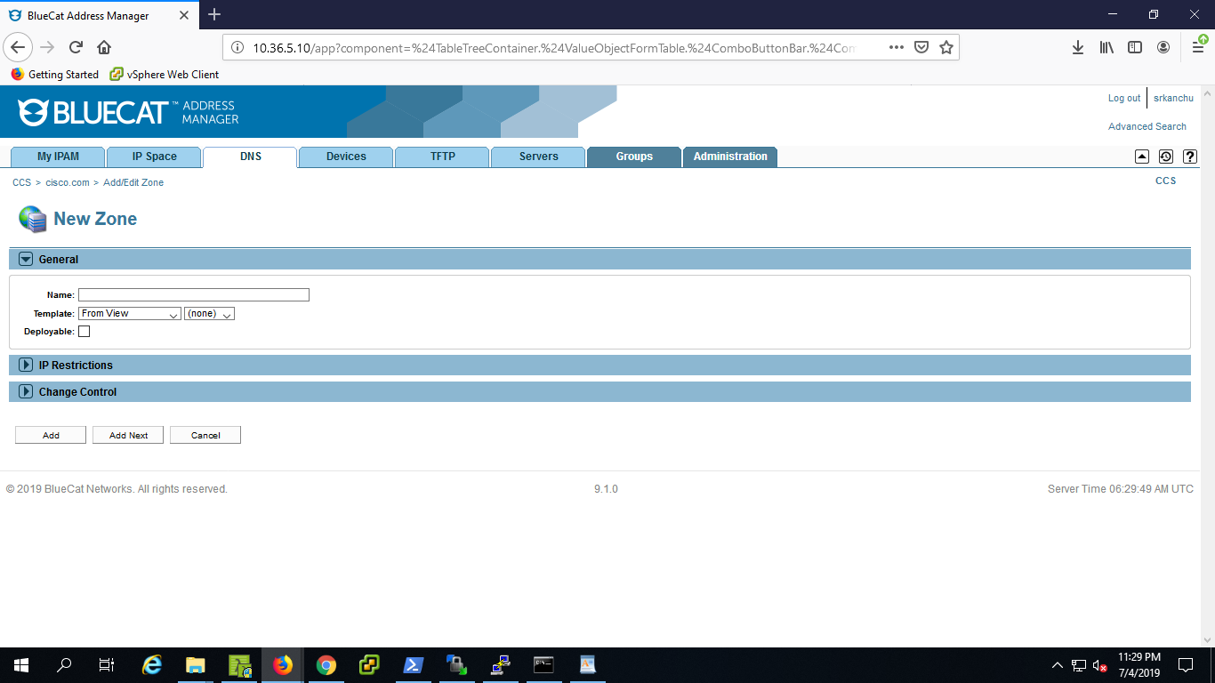

**Adding IPv4 Block and Ipv4 Network:**

Select your ***Configuration*** *in which you would like to do manage your IP Addresses.*

***Adding IPv4 Block:***

***Steps:***

1. Go to ***IP Space*** tab.

2. Go to ***IPv4*** sub tab in the ***IP Space*** Tab.

3. Click on ***new IPv4 block*** from the ***IPv4 Blocks*** section to add new IPv4 block

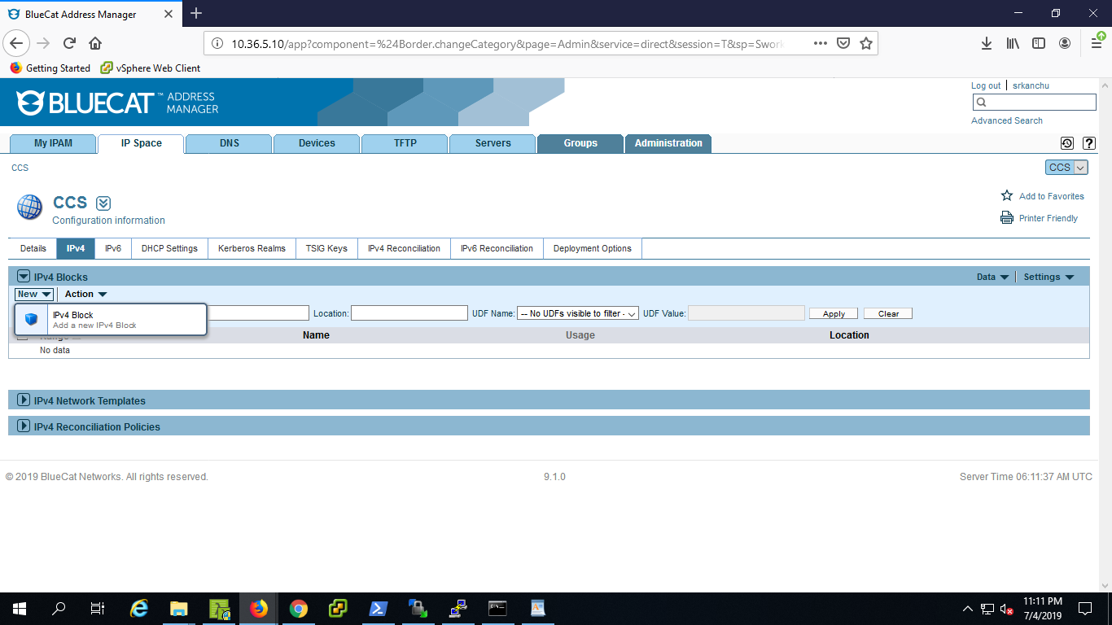

4. In general section give the details required.

***\*CIDR Block***: The network block in which your BlueCat address manager is configured. in valid notation(*.*.*.*/*)

**\*Name**: Give the name of the network (network name in which your Address Manager launched), which you have configured in VMWare data center (Network ID of the VMware data center configured in CCS).

Default View: select the **view**

Click on Assignment Options:

5. Select Duplicate Name Check and Ping Before Assign as Enable as per your requirement.

6. Click on ***Add***.

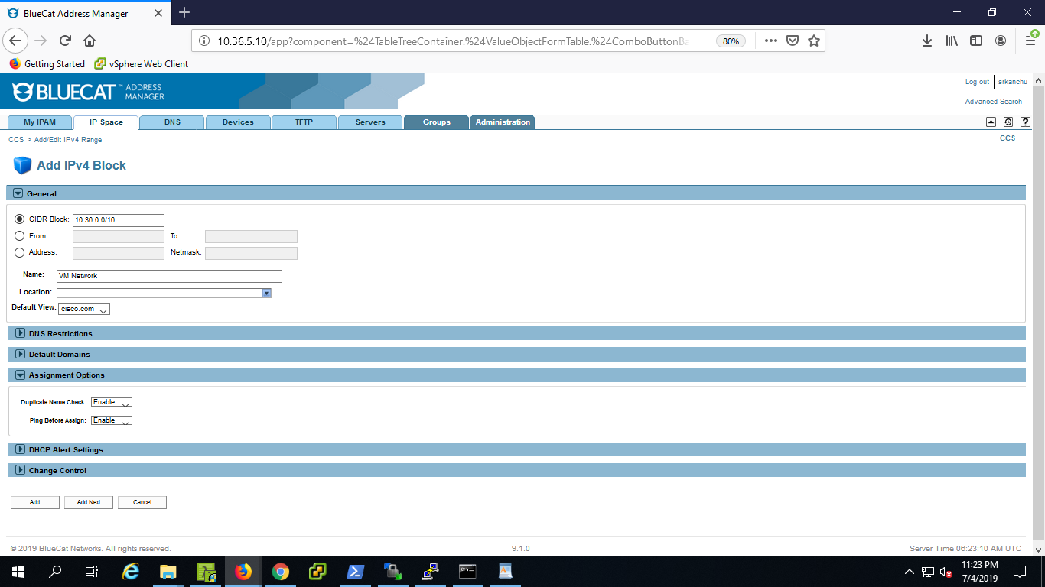

**Adding IPv4 Network:**

Go to the IPv4 Block created previously in the configuration you selected.

***Steps:***

1. Select the ***network block*** created from the ***IPv4 Blocks*** Section.

2. Now you are under ***IPv4 Blocks.***

3. Select the ***Address Space*** tab and create new ***IPv4 Network***.

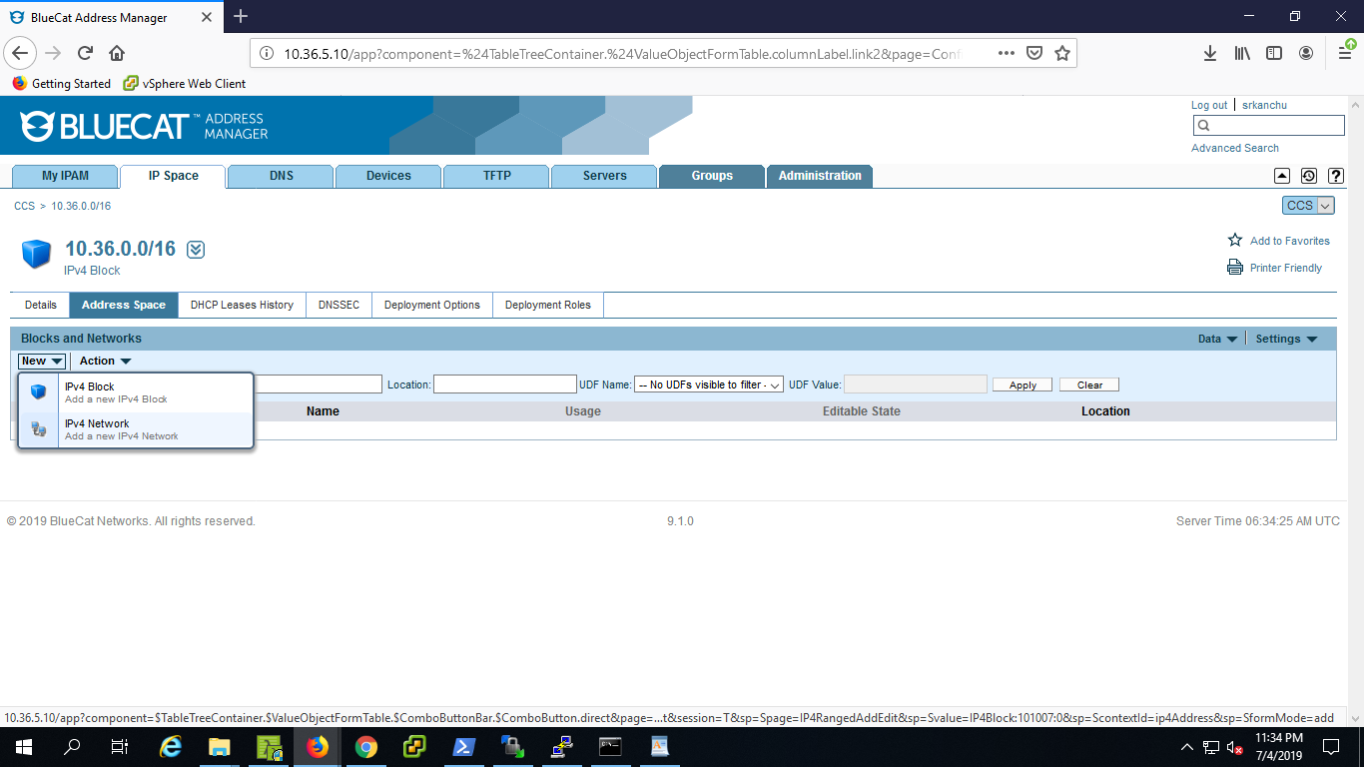

4.In general section give the required values.

***CIDR block*:** Provide Valid CIDR block, which is within the range of main block defined.

***Name*** and ***Location***: give these details as required.

***Default View***: Select the proper ***'View'*** from the drop down.

5. Expand "***Additional Information***" section and provide value to the custom field "**Gateway**" (Gateway address of the Network block defined).

6. Click on ***Add***.

**Network Discovery (Reconciliation Policy) :**

**Steps:**

1.Click on the network from the **Network block** on which you want to perform network descovery**.**

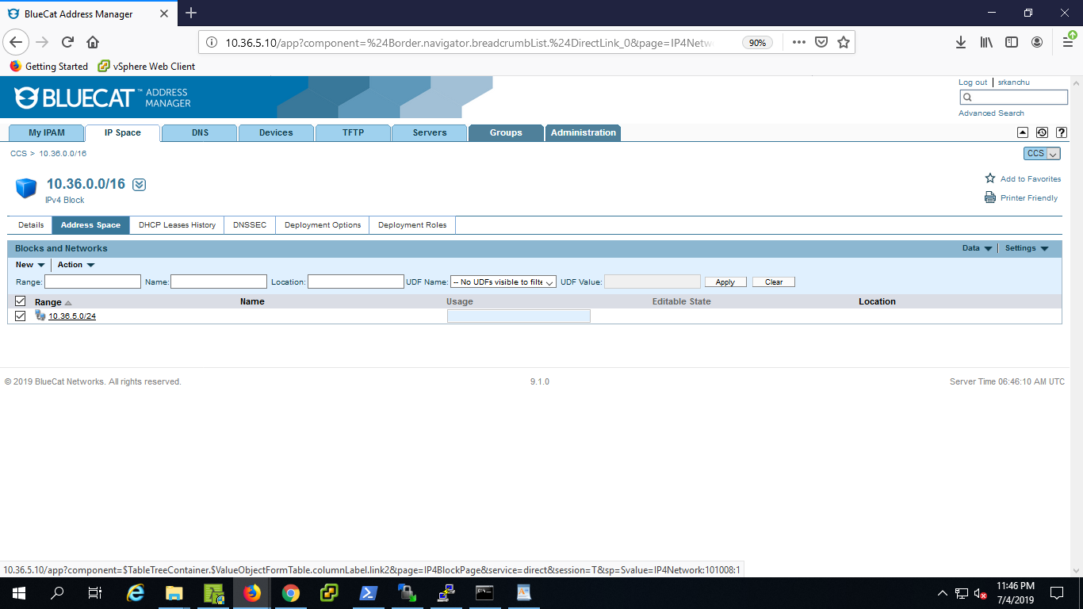

2. Now you are under the **IPv4 Network** page, you created.

3. Click on the ***Details*** Tab of the network.

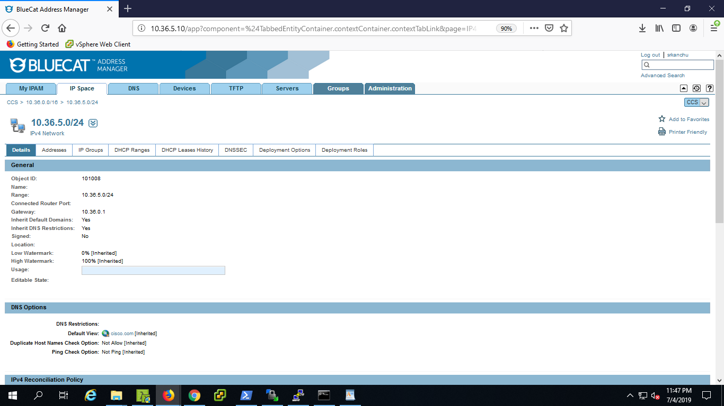

4. Go to "**IPv4 Reconciliation Policy**" section.

5. Click on **“Define Reconciliation Policy**”.

6. Now you are under **Add IPv4 Reconciliation Policy** page.

7. Select the "**Pingsweep only** " as Discovery method in "**Discovery Engine**" section.

8. Provide the details in the remaining sections as required.

9. Click on **Add.**

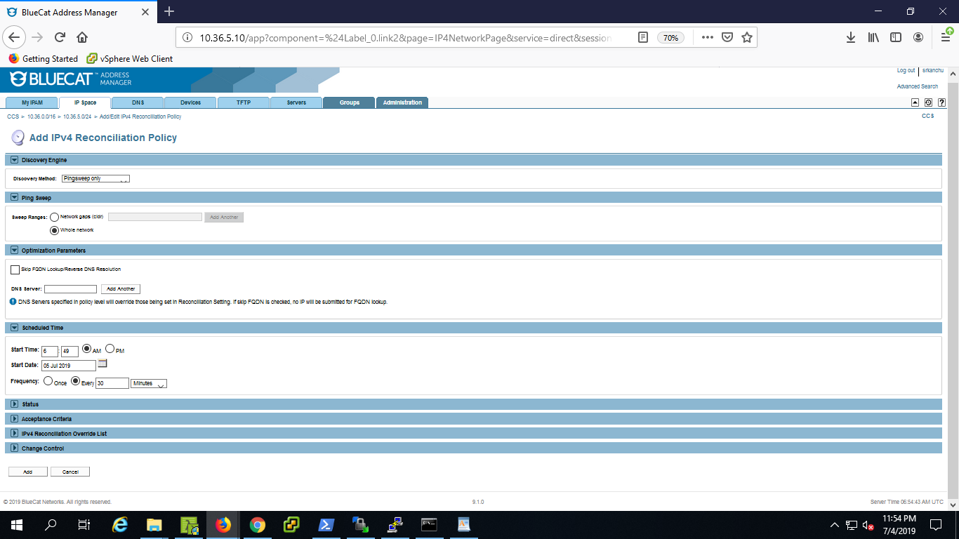

10 .Now run the Policy.

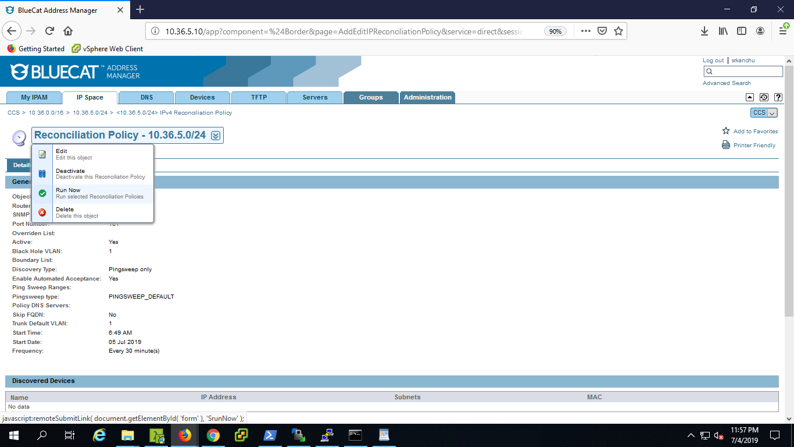

11 .Go to the "IPv4 Network " under the "IPv4 Block " and can be observed the whole network and find the state of the all IPs.

12. You can find the "Host Records" created from the service integration under **DNS**-->**Views**--> <**your view**> --> **Zones**--><**your zone**>-->**Resource Records**